###### **MTX-HSMC-160**

###### **High Speed Mezzanine**

###### **Connector**

###### **Adapter Board**

###### Rev 0

Table of Contents

1. Overview 3

2. Key specifications 3

3. Targeted application 4

4. Architecture 4

5. Protype area 5

6. Connection Tables 6

7. Ordering information 9

8. Revision history 9

8. Disclaimer 10

# Overview

The MTX-HSMC-160-0 is designed to convert its High-Speed Mezzanine connector I/O from 160 pins to three 44 pins, which results in 2 rows measured 0.1” (2.54mm).

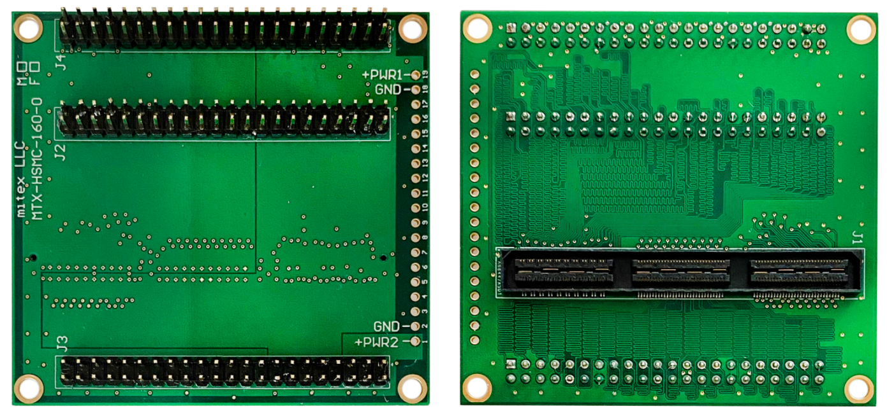

**Figure 1. MTX-HSMC-160-0** **board top and back side view. Female version.**

# Key specifications

* Uses three standard, two-row, 44-pin headers
* Each header is dedicated to one of the three banks of the HSMC
* Headers have a pitch of 2.54 mm (0.1 in)
* Equally sized data traces ensure optimal signal integrity
* Prototyping area with plated holes for creating small circuits when debugging hardware
* Dimensions: 7.3 x 6.8 x 1.3 cm

# Targeted application

Any application that requires a bridging between an HSMC interface to the standard 0.1” pitch connector.

# Architecture

Figure 2 depicts the layout of the board and indicates the locations of the connectors.

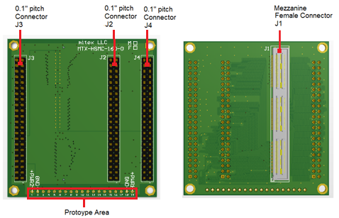

**Figure 2. MTX-HSMC-160-0** **top and back side of female version**

Figure 3 shows the block diagram of the MTX-HSMC-160-0 board.

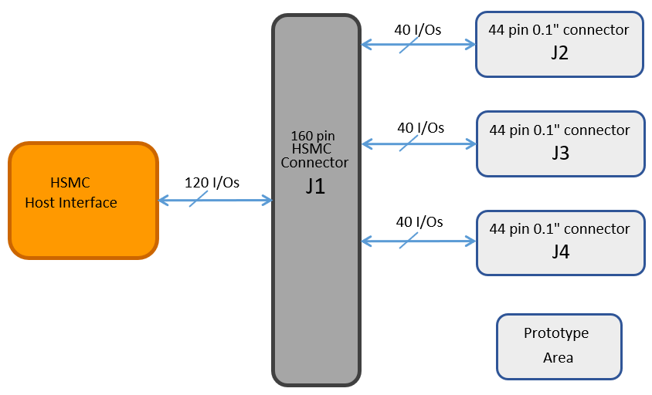

**Figure 3. MTX-HSMC-160-0** **block diagram**

# Protype area

Figure 4 shows the prototype area’s detailed view of the MTX-HSMC-160-0 board. Its holes are plated with a diameter measured 1mm.

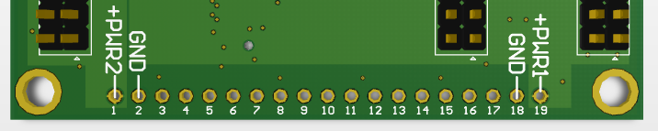

**Figure 4. MTX-HSMC-160-0** **protype area**

Each area’s holes have connections as follows:

Hole 1: +PWR2

Hole 2: GND

Holes 3-17: no connections

Hole 18: GND

Hole 19: +PWR1

# Connection Tables

Table 1 contains the Bank 1 connection information of the signals and power/ground mechanisms found in the HSMC and 0.1” pitch connectors of the MTX-HSMC-160-0 board.

**Table 1. Bank 1 connections**

|  |  |  |  |  |  |  |
| --- | --- | --- | --- | --- | --- | --- |
| **HSMC connector**  **J1** | **Connector**  **J2** | **HSMC connector**  **J1** | **Connector**  **J2** | **Power/Gnd** | **HSMC connector**  **J1** | **Connector**  **J2** |
| 1 | 1 | 21 | 23 | +PWR1 |  | 13 |
| 2 | 2 | 22 | 24 | +PWR2 |  | 31 |
| 3 | 3 | 23 | 25 | Gnd | 161 | 14 |
| 4 | 4 | 24 | 26 | Gnd | 162 | 32 |
| 5 | 5 | 25 | 27 | Gnd | 163 |  |
| 6 | 6 | 26 | 28 | Gnd | 164 |  |
| 7 | 7 | 27 | 29 |  |  |  |
| 8 | 8 | 28 | 30 |  |  |  |
| 9 | 9 | 29 | 33 |  |  |  |
| 10 | 10 | 30 | 34 |  |  |  |
| 11 | 11 | 31 | 35 |  |  |  |
| 12 | 12 | 32 | 36 |  |  |  |
| 13 | 15 | 33 | 37 |  |  |  |
| 14 | 16 | 34 | 38 |  |  |  |
| 15 | 17 | 35 | 39 |  |  |  |
| 16 | 18 | 36 | 40 |  |  |  |
| 17 | 19 | 37 | 41 |  |  |  |
| 18 | 20 | 38 | 42 |  |  |  |
| 19 | 21 | 39 | 43 |  |  |  |
| 20 | 22 | 40 | 44 |  |  |  |

Table 2 contains the Bank 2 connection information of the signals and power/ground mechanisms found in the HSMC and 0.1” pitch connectors of the MTX-HSMC-160-0 board.

**Table 2. Bank 2 connections**

|  |  |  |  |  |  |  |
| --- | --- | --- | --- | --- | --- | --- |
| **HSMC connector**  **J1** | **Connector**  **J3** | **HSMC connector**  **J1** | **Connector**  **J3** | **Power/Gnd** | **HSMC connector**  **J1** | **Connector**  **J3** |
| 41 | 1 | 77 | 27 | +PWR1 | 45 | 13 |
| 42 | 2 | 78 | 28 | +PWR1 | 51 |  |
| 43 | 3 | 79 | 29 | +PWR1 | 57 |  |
| 44 | 4 | 80 | 30 | +PWR1 | 63 |  |
| 47 | 5 | 83 | 33 | +PWR1 | 69 |  |
| 48 | 6 | 84 | 34 | +PWR1 | 75 |  |
| 49 | 7 | 85 | 35 | +PWR1 | 81 |  |
| 50 | 8 | 86 | 36 | +PWR1 | 87 |  |
| 53 | 9 | 89 | 37 | +PWR1 | 93 |  |
| 54 | 10 | 90 | 38 | +PWR1 | 99 |  |
| 55 | 11 | 91 | 39 | +PWR2 | 46 | 31 |
| 56 | 12 | 92 | 40 | +PWR2 | 52 |  |
| 59 | 15 | 95 | 41 | +PWR2 | 58 |  |
| 60 | 16 | 96 | 42 | +PWR2 | 64 |  |
| 61 | 17 | 97 | 43 | +PWR2 | 70 |  |
| 62 | 18 | 98 | 44 | +PWR2 | 76 |  |
| 65 | 19 |  |  | +PWR2 | 82 |  |
| 66 | 20 |  |  | +PWR2 | 88 |  |
| 67 | 21 |  |  | +PWR2 | 94 |  |
| 68 | 22 |  |  | +PWR2 | 100 |  |
| 71 | 23 |  |  | Gnd | 165 | 14 |
| 72 | 24 |  |  | Gnd | 166 | 32 |
| 73 | 25 |  |  | Gnd | 167 |  |
| 74 | 26 |  |  | Gnd | 168 |  |

Table 3 contains the Bank 3 connection information of the signals and power/ground mechanisms found in the HSMC and 0.1” pitch connectors of the MTX-HSMC-160-0 board.

**Table 3. Bank 3 connections**

|  |  |  |  |  |  |  |
| --- | --- | --- | --- | --- | --- | --- |
| **HSMC connector**  **J1** | **Connector**  **J4** | **HSMC connector**  **J1** | **Connector**  **J4** | **Power/Gnd** | **HSMC connector**  **J1** | **Connector**  **J4** |
| 101 | 1 | 137 | 27 | +PWR1 | 105 | 13 |
| 102 | 2 | 138 | 28 | +PWR1 | 111 |  |
| 103 | 3 | 139 | 29 | +PWR1 | 117 |  |
| 104 | 4 | 140 | 30 | +PWR1 | 123 |  |
| 107 | 5 | 143 | 33 | +PWR1 | 129 |  |
| 108 | 6 | 144 | 34 | +PWR1 | 135 |  |
| 109 | 7 | 145 | 35 | +PWR1 | 141 |  |
| 110 | 8 | 146 | 36 | +PWR1 | 147 |  |
| 113 | 9 | 149 | 37 | +PWR1 | 153 |  |
| 114 | 10 | 150 | 38 | +PWR1 | 159 |  |
| 115 | 11 | 151 | 39 | +PWR2 | 106 | 31 |
| 116 | 12 | 152 | 40 | +PWR2 | 112 |  |
| 119 | 15 | 155 | 41 | +PWR2 | 118 |  |
| 120 | 16 | 156 | 42 | +PWR2 | 124 |  |
| 121 | 17 | 157 | 43 | +PWR2 | 130 |  |
| 122 | 18 | 158 | 44 | +PWR2 | 136 |  |
| 125 | 19 |  |  | +PWR2 | 142 |  |
| 126 | 20 |  |  | +PWR2 | 148 |  |
| 127 | 21 |  |  | +PWR2 | 154 |  |
| 128 | 22 |  |  | +PWR2 | 160 |  |
| 131 | 23 |  |  | Gnd | 169 | 14 |
| 132 | 24 |  |  | Gnd | 170 | 32 |
| 133 | 25 |  |  | Gnd | 171 |  |
| 134 | 26 |  |  | Gnd | 172 |  |

# Ordering information

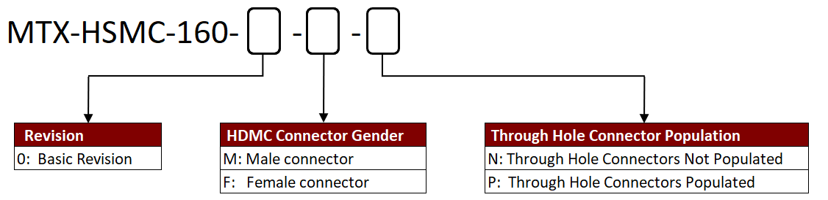

# Revision history

|  |  |  |
| --- | --- | --- |
| **Date** | **Version** | **Revision** |
| 7/22/2020 | 0 | Original revision |
|  |  |  |
|  |  |  |

# Disclaimer

We expressly disclaim any liability arising out of the application or use of the MTX-HSMC-160-0. We reserve the right to make changes, at any time, to the MTX-HSMC-160-0 as deemed desirable in the sole discretion of ours. We assume no obligation to correct any errors contained herein or to advise you of any correction if such be made. We will not assume any liability for the accuracy or correctness of any engineering or technical support or assistance provided to you in connection with the MTX-HSMC-160-0.

THE DESIGN IS PROVIDED “AS IS” WITH ALL FAULTS, AND THE ENTIRE RISK AS TO ITS FUNCTION AND IMPLEMENTATION IS WITH YOU. YOU ACKNOWLEDGE AND AGREE THAT YOU HAVE NOT RELIED ON ANY ORAL OR WRITTEN INFORMATION OR

ADVICE, WHETHER GIVEN BY US, OR OUR AGENTS OR EMPLOYEES. WE MAKE NO OTHER WARRANTIES, WHETHER EXPRESS, IMPLIED, OR STATUTORY, REGARDING THE DESIGN, INCLUDING ANY WARRANTIES OF MERCHANTABILITY, FITNESS FOR A PARTICULAR PURPOSE, TITLE, AND NONINFRINGEMENT OF THIRD-PARTY RIGHTS.

The MTX-HSMC-160-0 is not designed or intended for use in the development of on-line control equipment in hazardous environments requiring fail-safe controls, such as in the operation of nuclear facilities, aircraft navigation or communications systems, air traffic control, life support, or weapons systems (“High-Risk Applications”). We specifically disclaim any express or implied warranties of fitness for such High-Risk Applications. You represent that use of the MTX-HSMC-160-0 in such High-Risk Applications is fully at your risk.